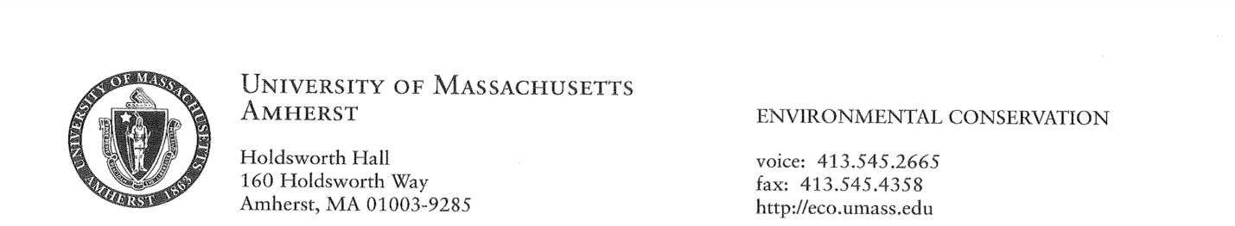

MEMORANDUM

Date:
To: Patrick Sullivan, Graduate Registrar
From: Timothy Randhir, ECo Graduate Program Director
Subject: Graduate Committee for Student Name (Student ID)
I recommend the following members to serve as the MS Committee of Student name in the Environmental Conservation (ECo) Graduate Program:

____________________________________, Chair
____________________________________, Member
____________________________________, Outside Member (optional)
____________________________________, Consulting Member (optional)

_____________________________________
Timothy Randhir, Graduate Program Director,
Environmental Conservation

